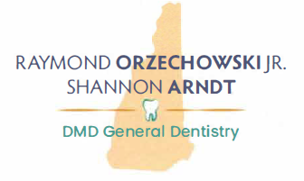
March 25, 2024
To My Valued Patients,
After 34 years of providing dental service in the Concord area, it is time to begin my retirement. It has been my supreme pleasure to have provided the best possible dental care during this time to so many of you, and the trust and confidence I have been afforded is something I will always treasure. Over the next few months as I decrease my office hours, I hope I can personally thank as many of you as possible for giving me the opportunity to be your dentist.
As part of this transition, it gives Dr. Arndt and me great pleasure to welcome Dr. Anthony Francis, DMD to our practice, beginning April 22. We believe we have found someone who will continue the excellence in quality of service that you currently receive. Dr. Francis received his BS in Psychology from UMass Amherst and is a graduate of Boston University Goldman School of Dental Medicine. He is a native of Salem, NH and is excited to have the opportunity to join our amazing team of providers and staff. We welcome the opportunity to accept new patients into the practice at this time.
As I look forward to the next chapter of my life, I will continue to reflect on the incredible sense of fulfillment and connection I have shared with so many of you. Being your dentist has been personally and professionally gratifying, and it has been tremendously rewarding to have shared that with all of you.
Sincerely,
